**Project Proposal for Visitor Badging System**

**Sourabh Pandya  
 Syracuse University**

**sourabhpandya7@outlook.com**

**Project Summary**

This proposal describes the creation of an advanced visitor badging system that uses artificial intelligence and automation technologies. Drawing from professional experience in automation and system integration at IBM and Capgemini, the project aims to revolutionize how visitor management works by incorporating facial recognition technology (via Ozwell.ai), optical character recognition for document processing, and integration with HubSpot CRM. The goal is to create a seamless, automated check-in process that improves both security measures and operational effectiveness while eliminating manual steps in visitor management.

**Objectives**

* Seamlessly onboard visitors with facial recognition or ID/business card scanning.
* Eliminate redundant visitor data entry via HubSpot integration.
* Generate secure, professional visitor badges in real-time.
* Provide a comparative analysis between building a custom solution and buying existing SaaS platforms (e.g., LobbyTrack).

**Current Visitor Management Landscape**

Existing visitor management systems suffer from critical limitations:

* Manual Data Entry: Visitors manually input information at kiosks, creating bottlenecks
* Duplicate Records: No integration with CRM systems leads to redundant entries
* Security Gaps: Paper logs and generic badges enable tailgating risks
* Poor Experience: Lengthy check-in processes frustrate visitors
* No Intelligence: Systems lack predictive capabilities for returning visitors
* Disconnected Workflows: Badge printing operates independently from security databases.

**Scope of Work**

| **Area** | **Tasks** |
| --- | --- |
| Check-in UI | Facial recognition camera input, OCR from IDs/cards |
| Data Extraction | Use Ozwell.ai APIs to process image and text data |
| CRM Integration | Push visitor info to HubSpot via Contacts API |
| Badge Printing | Auto-generate and print visitor badges |
| Protocol Layer | Evaluate use of A2A/MCP for distributed agent interaction |
| Build-vs-Buy Study | Assess feasibility, cost, and features |

**Strategic Improvements**

**1. AI-Powered Visitor Identification**

* Facial recognition via Ozwell.ai for returning visitors
* OCR scanning of driver's licenses/business cards for new visitors
* Automated duplicate prevention across HubSpot and internal CMS

**2. End-to-End Automation**

* Raspberry Pi-controlled badge printing triggered by identification
* Real-time security database updates
* Automated welcome email/SMS notifications

3**. Intelligent Integration Layer**

**High level process flow Diagram**

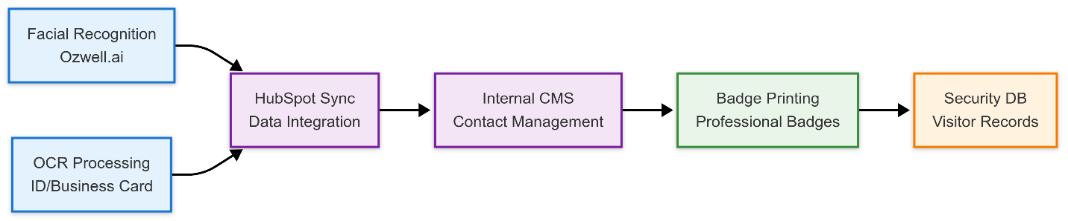

**Detailed Architecture Diagram**

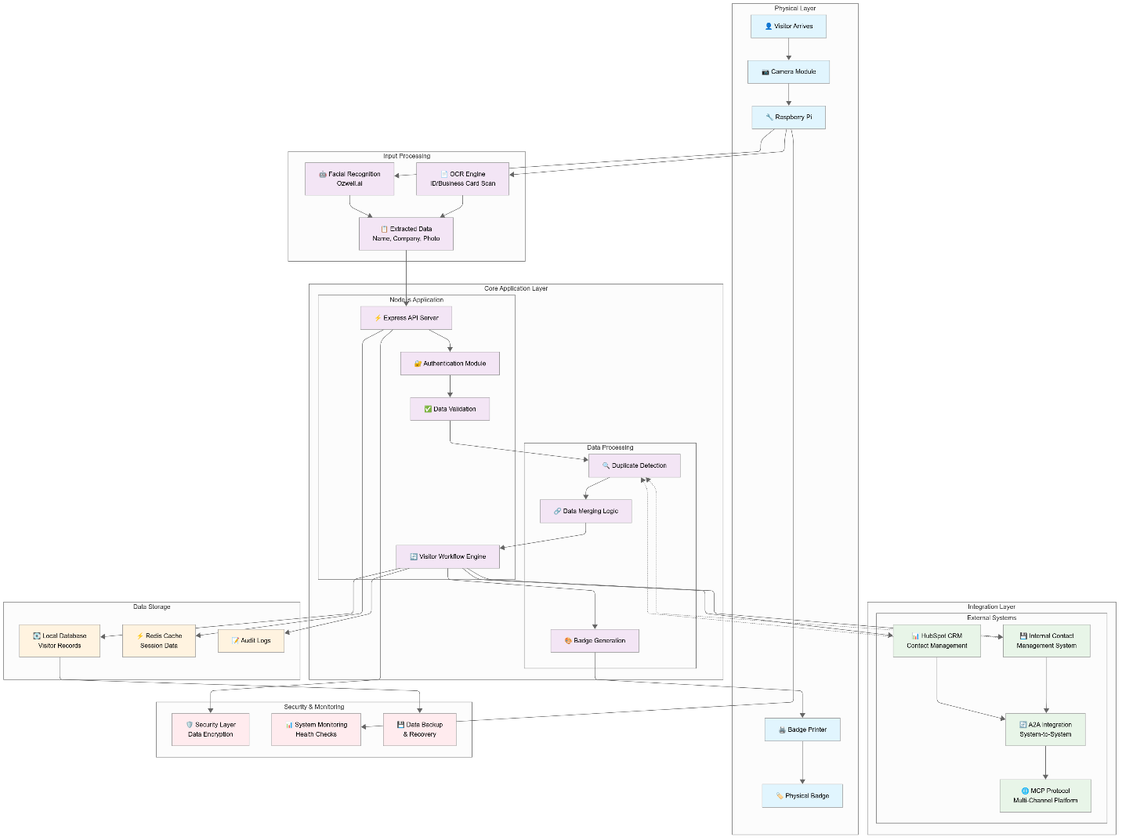

**4. Process Optimization**

* Visitor journey redesign reducing check-in time by 60%
* Compliance-ready audit trails (GDPR/CCPA/HIPAA)
* Predictive analytics for frequent visitor preferences

**Project Roadmap**

| **Week** | **Milestone** | **Key Deliverables** | **Integration Focus** |
| --- | --- | --- | --- |
| **1** | Research, Requirements, Build-vs-Buy Report | - Stakeholder interviews - Requirement doc - Comparative analysis (LobbyTrack vs. custom build) | Tech feasibility study Build-vs-buy criteria matrix |
| **2** | Ozwell Integration for Facial Recognition and OCR | - Functional API calls to Ozwell - Demo of facial recognition & OCR accuracy | Ozwell vision module integration API authentication setup |
| **3** | Basic Visitor Check-In UI + Raspberry Pi Setup | - Kiosk-style UI (HTML/JS) - Camera setup and feed capture - Raspberry Pi configuration | Device-to-backend communication UI capture trigger logic |
| **4** | HubSpot Contact Sync | - API connection to HubSpot - Create/update contact logic - Data validation rules | CRM deduplication Email/phone as unique IDs |
| **5** | Badge Printer Integration | - On-demand badge print feature - Printer driver/interface connected to RPi | Print layout logic Badge preview and error handling |
| **6** | End-to-End Demo, Documentation, Evaluation Report | - Fully integrated system demo - Project documentation - Stakeholder review | Final validation User feedback loop & deployment prep |

**Impact and Outcomes**

**Operational Transformation:**

* 80% reduction in manual data entry
* 60% faster check-in experience
* 100% elimination of duplicate visitor records

**Technical Innovation:**

* First AI-powered visitor management system with HubSpot integration
* Patentable hardware/software interface design
* Reusable automation framework for other facility systems

**Required Resources**

1. **Hardware**
   * Raspberry Pi
   * Camera (compatible with Raspberry Pi)
   * Thermal Badge Printer
2. **Software**
   * Node.js backend with Express framework
   * Frontend: Minimal kiosk UI (HTML, CSS, JavaScript)
   * Ozwell.ai Vision APIs (facial recognition, OCR)
   * HubSpot Contacts API (CRM integration)
   * Protocol Layer (optional/experimental): A2A and MCP for modular agent interactions
3. **Stakeholder Access**
   * Security team for compliance requirements
   * Facilities management for deployment planning
   * Marketing for visitor experience feedback

**Conclusion**This project, informed by my professional experience in automation, integration, and process optimization, aims not just to modernize visitor management but to redefine how organizations handle visitor interactions through intelligent technology. By combining facial recognition, OCR processing, and seamless CRM integration, it represents a step towards more efficient, secure visitor management solutions, ultimately contributing to enhanced facility security, operational excellence, and superior visitor experiences.